Hordacre, Alan
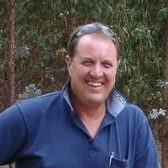
Trained at Dwellingup Cadet School and Mt Lawley Tech. Graduated 1976. Worked for Forests Department and CALM. Promoted to Senior Forester at Collie in 1989. Resigned. Worked for Great Southern Plantations. Now self employed Forester, Farmer & Accommodation Provider by the Southern Ocean Denmark WA.

